**Part 1**

* **Step 2:**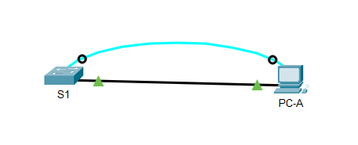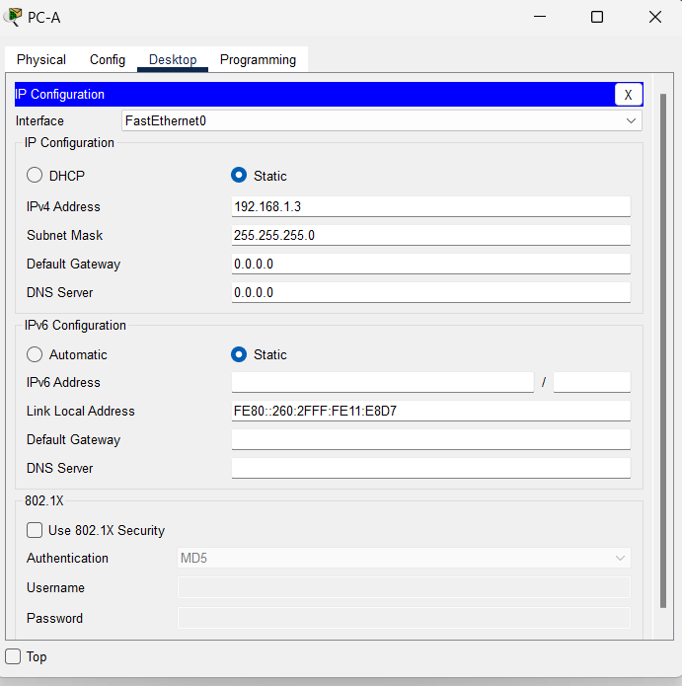
* No, because the switch has not been configured yet

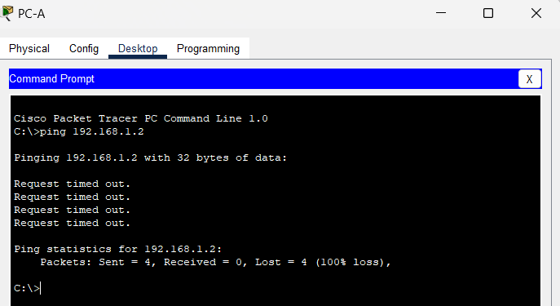

* **Step 4:** Yes, it’s successful.

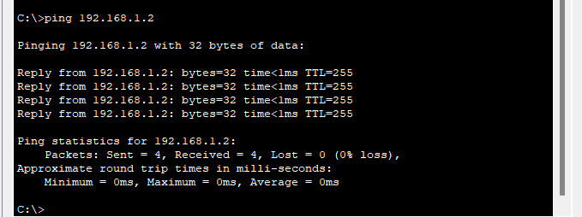

**Part 2**

* **Step 1**

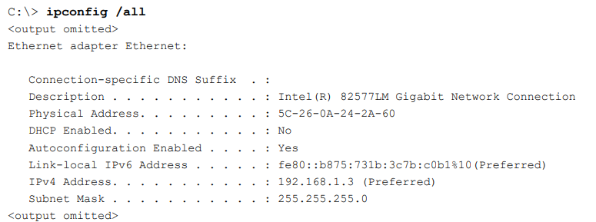

* What is the OUI portion of the MAC address for this device?

**OUI**: 5C-26-0A

* What is the serial number portion of the MAC address for this device?

**Serial number portion**: 24-2A-60

* Using the example above, find the name of the vendor that manufactured this NIC.

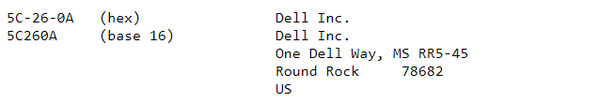

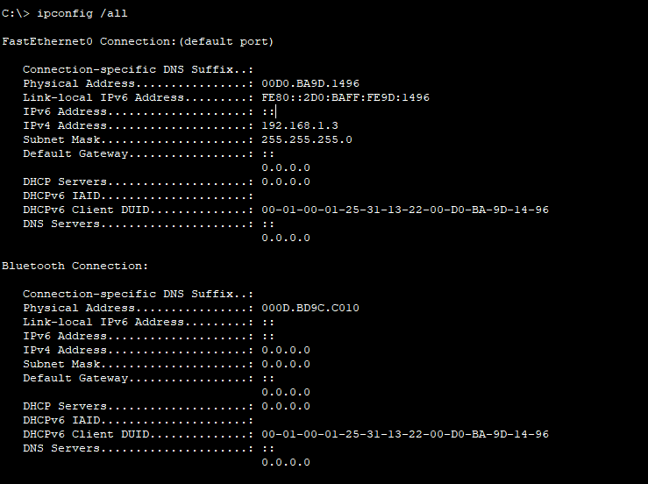

* From the command prompt on PC-A, issue the ipconfig /all command and identify the OUI portion of the MAC address for the NIC of PC-A.

**OUI**: 5C-26-0A

* Identify the serial number portion of the MAC address for the NIC of PC-A.

**Serial number portion**: 9D.1496

* Identify the name of the vendor that manufactured the NIC of PC-A.

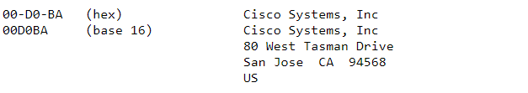

* **Step 2**

**a,**

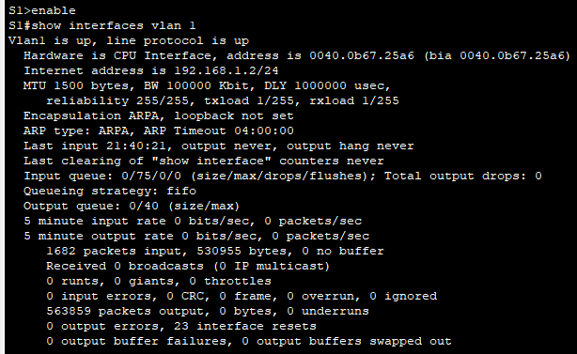

* What is the MAC address for VLAN 1 on S1?

**0040.0b67.25a6**

* What is the MAC serial number for VLAN 1?

**67.25a6**

* What is the OUI for VLAN 1?

**0040.0b**

* Based on this OUI, what is the name of the vendor?

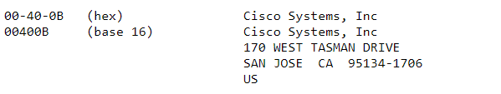

* What does bia stand for?

**bia** stands for **Burned-In Address**

* Why does the output show the same MAC address twice?

The MAC address is listed twice because one instance shows the **burned-in address (bia)**, which is the permanent hardware address, and the other shows the **current MAC address** in use by the interface.

b, 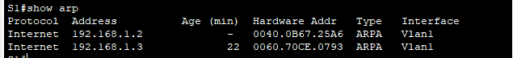

* What Layer 2 addresses are displayed on S1?

**0040.0B67.25A6**

**0060.70CE.0793**

* What Layer 3 addresses are displayed on S1?

**192.168.1.2**

**192.168.1.3**

* **Step 3**

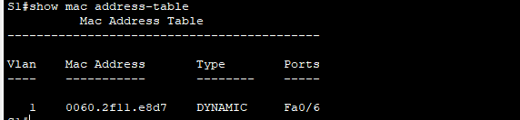

Did the switch display the MAC address of PC-A? If you answered yes, what port was it on?

**Yes, in Fa0/6 port**

**Reflection Questions**

1. **Can you have broadcasts at the Layer 2 level? If so, what would the MAC address be?**

* Yes, broadcasts can occur at the Layer 2 level.
* The MAC address for a broadcast is **FF:FF:FF:FF:FF**
* It sends data to all devices on the local network segment.

1. **Why would you need to know the MAC address of a device?**

* To uniquely identify devices on a local network.
* For troubleshooting network issues (e.g., ARP conflicts).
* To filter or block devices using MAC filtering in network security.
* To map IP addresses to MAC addresses (e.g., using ARP).